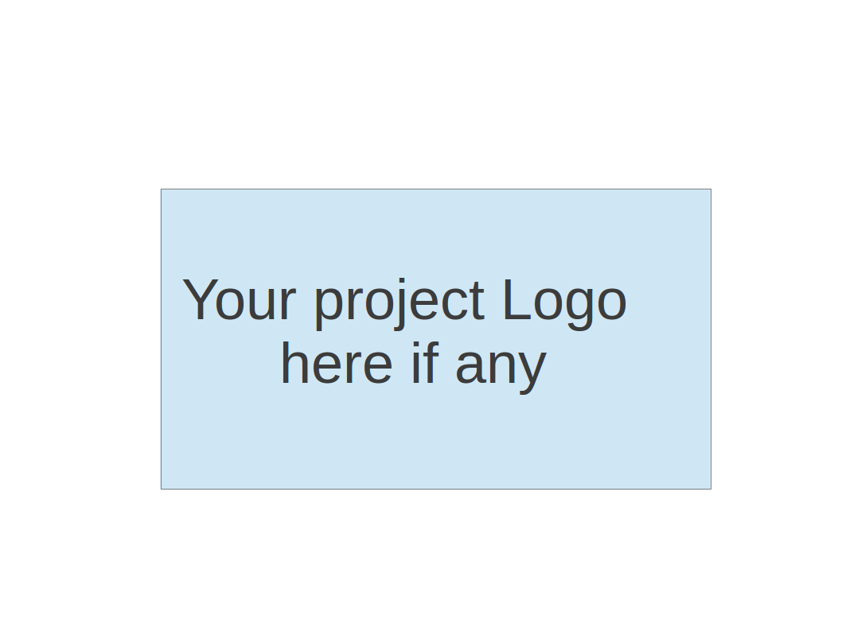
CS673 Software Engineering
Team 4 - ResumAI
Software Test Document

Team Member | Role(s) | Signature | Date
Hemant Krishnakumar | Team Lead |  | 11-07-2024
Faizan Ahmad | Design and Implementation Lead |  | 11-07-2024
Tushar | Requirement Lead |  | 11-07-2024
Shubh Gupta | Q/A Lead |  | 11-07-2024
Amruth Reddy | Security Lead |  | 11-07-2024
Jaindra Parvathaneni | Configuration Lead |  | 11-07-2024

Revision history
Version | Author | Date | Change
1 | Shubh Gupta | 11-07-2024 | New

Testing Summary
Manuel Tests Reports
Automated Testing Reports
Testing Metrics
References
Glossary

Testing Summary

- Tested Components: Key frontend and backend units like login, registration, and recruiter shortlist.
- Involved: Development team, with QA input on test cases.
- Timing: Unit tests during development; automated tests on every commit via Husky.
- Techniques: Unit testing with Jest, Husky pre-commit hooks, mocking, and snapshot testing.
- Results: All unit tests passed; minor issues fixed; Husky successfully blocks commits with errors.

Manual Testing Report
Test Case 1: Login Page
- New or Old: New
- Test Items: Verifying login functionality with correct and incorrect credentials
- Test Priority: High
- Dependencies: Registration Page
- Preconditions: User must be registered in the system
- Input Data: Valid and invalid email/password combinations
- Test Steps:
  - Navigate to the login page.
  - Enter valid credentials and submit.
  - Enter invalid credentials and submit.
- Postconditions: User is redirected to the homepage on successful login, receives an error on failure.
- Expected Output: Successful login redirects to the homepage; unsuccessful login displays an error message.
- Actual Output: Redirects to the homepage on success; error message on failure.
- Pass or Fail: Pass
- Bug ID/Link: N/A
- Additional Notes: N/A

Test Case 2: Registration Page
- New or Old: Old
- Test Items: Verifying registration with valid and invalid data
- Test Priority: High
- Dependencies: Login Page
- Preconditions: None
- Input Data: Various email/password combinations, including valid, invalid, and duplicate data
- Test Steps:
  - Navigate to the registration page.
  - Enter valid user details and submit.
  - Attempt registration with duplicate email and invalid data.
- Postconditions: Registration completes successfully, or the user is informed of errors.
- Expected Output: Successful registration redirects to the login page; errors are shown for invalid data.
- Actual Output: Works as expected.
- Pass or Fail: Pass
- Bug ID/Link: N/A
- Additional Notes: Check for edge cases with duplicate registrations.

Test Case 3: Analytics Page
- New or Old: New
- Test Items: Verify analytics page data loads and displays correctly
- Test Priority: Medium
- Dependencies: None
- Preconditions: User must be logged in
- Input Data: N/A
- Test Steps:
  - Log in and navigate to the analytics page.
  - Verify that data loads correctly for each category.
- Postconditions: Data appears as expected.
- Expected Output: All graphs and data should load and be interactive.
- Actual Output: Data loads with slight delays in some sections.
- Pass or Fail: Pass
- Bug ID/Link: N/A
- Additional Notes: Consider optimizing load times.

Test Case 4: Shortlist Page
- New or Old: New
- Test Items: Verify adding and removing candidates from the shortlist
- Test Priority: Medium
- Dependencies: Job listing page
- Preconditions: User must have viewed job listings
- Input Data: Candidate profiles
- Test Steps:
  - Navigate to the shortlist page.
  - Attempt to add candidates to the shortlist.
  - Remove candidates from the shortlist.
- Postconditions: Candidate is added or removed from the shortlist.
- Expected Output: Candidates appear in the shortlist; removal works as expected.
- Actual Output: Works as expected.
- Pass or Fail: Pass
- Bug ID/Link: N/A
- Additional Notes: Ensure shortlist updates in real time.

Test Case 5: Job Listing Page
- New or Old: Old
- Test Items: Verify job listings load and filters function correctly
- Test Priority: High
- Dependencies: Login Page
- Preconditions: User must be logged in
- Input Data: Job titles, company names, and filters
- Test Steps:
  - Navigate to the job listing page.
  - Apply various filters and sort options.
  - Open specific job listings.
- Postconditions: Filtered jobs load and details display correctly.
- Expected Output: Job listings display as per applied filters.
- Actual Output: Works as expected.
- Pass or Fail: Pass
- Bug ID/Link: N/A

Test Case 6: Landing Page
- New or Old: Old
- Test Items: Verify landing page content and responsiveness
- Test Priority: Low
- Dependencies: None
- Preconditions: None
- Input Data: N/A
- Test Steps:
  - Navigate to the landing page.
  - Check content and responsiveness across devices.
- Postconditions: Page should load quickly and be responsive.
- Expected Output: Content displays correctly on all screen sizes.
- Actual Output: Works as expected.
- Pass or Fail: Pass
- Bug ID/Link: N/A
- Additional Notes: Test on different browsers and devices.

Automated Testing Report

Husky in Automated Testing
- Purpose: Husky is used to enforce pre-commit hooks, automatically running tests and checks to ensure code quality before each commit.
- Pre-commit Hooks: When a developer commits code, Husky triggers:
- Jest Tests: Runs unit tests to verify core functionality and catch issues in new changes.
- Nodetap Tests: Executes server-side tests, particularly for Node.js components, ensuring backend stability.
- Linting: ESLint checks for code style and formatting errors.
- Commit Blocking: If any test fails, Husky blocks the commit, ensuring issues are fixed before pushing code.
- Configuration: Configured in the .husky directory at the project root, specifying commands for linting, Jest, and Nodetap tests in the pre-commit hook.
Husky’s integration ensures consistent code quality by catching potential issues early in the development workflow.

References

- Jest Documentation - https://jestjs.io/docs/getting-started
- Husky Documentation - https://typicode.github.io/husky/#/
- Nodetap Testing Framework - https://www.npmjs.com/package/tap
- ESLint Documentation - https://eslint.org/docs/user-guide/getting-started

